**Mobile Application Development (3170726)**



**VVP**

**Engineering**

**College**

Submitted by: **DISHEN MAKWANA**

**180470107035**

**G2**

 **V. V. P. Engineering College, Rajkot**

**Department of Computer Engineering**

**Vision of the** **Institute**

* To be an exemplary institute, transforming students into competent

professionals with human values.

**Mission of the Institute**

* To provide a conducive academic environment for strengthening technical capabilities of the students.
* To strengthen linkage with industries, alumni and professional bodies.
* To organize various co-curricular and extra-curricular activities for overall development of the students.
* To practice good governance and conduct value- based activities for making students responsible citizens.

**Vision of the Department**

* Transforming students into globally efficient professionals with moral values.

**Mission of the Department**

* To provide a strong foundation of computer engineering through effective teaching learning process.
* To enhance industry linkage & alumni network for better placement and real-world exposure.
* To provide various opportunities & platforms for all round development of students & encourage them for value-based practices.

**Program Educational Objectives (PEOs)**

Graduates will be able to

* Apply computer engineering theories, principles and skills to meet the challenges of the society.
* Communicate effectively, work collaboratively and manifest professionalism with ethics.
* Exhibit life-long learning attitude and adapt to rapid technological changes in industry.
* Advance their career in industry, pursue higher education or become an entrepreneur.

**Program Specific Outcomes (PSO)**

Graduates will be able to

* **PSO1**: Apply fundamental knowledge of hardware and software aspects of computer systems.
* **PSO2**: Analyze, model and develop computer applications by adapting emerging technologies and standard practices of software project development to meet the requirements of industry and society.
* **PSO3**: Use different programming languages and open-source platforms.

## V.V.P. ENGINEERING COLLEGE

**RAJKOT**

**Certificate**

This is to certify that

Mr. DISHEN MAKWANA, Enrollment No: 180470107035, Branch: Computer Engineering, Semester: 7 has satisfactorily completed the course in the subject: **Mobile Application Development (3170726)** within the four walls of V.V.P. Engineering College, Rajkot.

Date of Submission:

**Prof. Nivid Limbasiya**, Head of Department,

Staff In-Charge Department of Computer Engineering,

V.V.P. Engineering College

**V. V. P. Engineering College**

**Department of Computer Engineering**

**Course Outcomes**

Semester: 7th

Subject: Mobile Application Development

Code: 3170726

After learning the course, the students will be able to

|  |  |
| --- | --- |
| **Sr.**  **No.** | **CO statement** |
| CO-1 | Understand Android architecture, activities and their life cycle. |
| CO-2 | Apply the knowledge to design user interface using Android UI And Component |
| CO-3 | Manage system database, remote database operations using web services and Firebase |
| CO-4 | Apply knowledge of map, location services, Graphics, android system and background services |
| CO-5 | Publish and distribute Android Application |

**Index**

|  |  |  |  |  |
| --- | --- | --- | --- | --- |
| **Sr.**  **No.** | **Question/Task** | **Page** | **Sign** | **Grades** |
| **Assignment - 1** | | | | |
| **1** | Explain the Android Architecture. | 6 |  |  |
| **2** | Implement Calculator. | 8 |  |  |
| **3** | Implement Intent project. | 20 |  |  |
| **4** | Implement Math Game. | 22 |  |  |
| **5** | Implement MP3 Player. | 25 |  |  |
| **6** | Implement Note Take App. | 30 |  |  |
| **7** | Implement Number guessing game. | 38 |  |  |
| **8** | Implement online examination system. | 41 |  |  |
| **9** | Implement periodic notification. | 46 |  |  |
| **10** | Implement phone call app. | 48 |  |  |
| **11** | Implement Speech to text app. | 51 |  |  |
| **12** | Implement Weather app. | 54 |  |  |
| **Assignment – 2** | | | | |
| **1** | Mini Project | 60 |  |  |

**Assignment – 1**

1. **Explain the Android Architecture.**

Android architecture is a software stack of components to support mobile device needs. Android software stack contains a Linux Kernel, collection of c/cpp libraries which are exposed through an application framework services, runtime, and application.

Following are main components of android architecture those are

1. Applications

2. Android Framework

3. Android Runtime

4. Platform Libraries

5. Linux Kernel

In these components, the Linux Kernel is the main component in android to provide its operating system functions to mobile and Dalvik Virtual Machine (DVM) which is responsible for running a mobile application.

Following is the pictorial representation of android architecture with different components.

**Applications**

The top layer of the android architecture is Applications. The native and third-party applications like contacts, email, music, gallery, clock, games, etc. whatever we will build those will be installed on this layer only.

The application layer runs within the Android run time using the classes and services made available from the application framework.

**Application** **Framework**

The Application Framework provides the classes used to create Android applications. It also provides a generic abstraction for hardware access and manages the user interface and application resources. It basically provides the services through which we can create a particular class and make that class helpful for the Application creation.

The application framework includes services like telephony service, location services, notification manager, NFC service, view system, etc. which we can use for application development as per our requirements.

**Android** **Runtime**

Android Runtime environment is an important part of Android rather than an internal part and it contains components like core libraries and the Dalvik virtual machine. The Android run time is the engine that powers our applications along with the libraries and it forms the basis for the application framework.

**Dalvik** **Virtual** **Machine** (DVM) is a register-based virtual machine-like Java Virtual Machine (JVM). It is specially designed and optimized for android to ensure that a device can run multiple instances efficiently. It relies on the Linux kernel for threading and low-level memory management.

The core libraries in android runtime will enable us to implement android applications using standard JAVA programming language.

**Platform** **Libraries**

The Platform Libraries includes various C/C++ core libraries and Java-based libraries such as SSL, libc, Graphics, SQLite, Webkit, Media, Surface Manger, OpenGL, etc. to provide support for Android development.

The following are the summary details of some core android libraries available for android development.

• Media library for playing and recording audio and video formats

• The Surface manager library to provide a display management

• SGL and OpenGL Graphics libraries for 2D and 3D graphics

• SQLite is for database support and Free Type for font support

• Web-Kit for web browser support and SSL for Internet security.

**Linux** **Kernel**

Linux Kernel is a bottom layer and heart of the android architecture. It manages all the drivers such as display drivers, camera drivers, Bluetooth drivers, audio drivers, memory drivers, etc. which are mainly required for the android device during the runtime.

The Linux Kernel will provide an abstraction layer between the device hardware and the remainder of the stack. It is responsible for memory management, power management, device management, resource access, etc.

1. **Implement Calculator.**

**Activity_main.xml**

<?xml version="1.0" encoding="utf-8"?>

<LinearLayout xmlns:android="http://schemas.android.com/apk/res/android"

xmlns:app="http://schemas.android.com/apk/res-auto"

xmlns:tools="http://schemas.android.com/tools"

android:layout_width="match_parent"

android:layout_height="match_parent"

tools:context=".MainActivity"

android:orientation="horizontal">

<LinearLayout

android:layout_width="match_parent"

android:layout_height="wrap_content"

android:orientation="vertical">

<TextView

android:layout_width="match_parent"

android:layout_height="90dp"

android:textSize="30sp"

android:id="@+id/textViewHistroy"

android:gravity="center|end"

android:background="@color/white"

android:textColor="@color/black"/>

<TextView

android:id="@+id/textViewResult"

android:layout_width="match_parent"

android:layout_height="106dp"

android:background="@color/white"

android:gravity="center|end"

android:text="0"

android:textColor="@color/black"

android:textSize="60sp" />

<androidx.gridlayout.widget.GridLayout

android:layout_width="match_parent"

android:layout_height="411dp"

app:columnCount="4"

app:rowCount="5">

<Button

android:id="@+id/btnDel"

android:layout_width="80dp"

android:layout_height="wrap_content"

android:text="DEL"

android:textColor="@color/orange"

android:textSize="30sp"

app:backgroundTint="#FDFDFD"

app:layout_column="1"

app:layout_columnWeight="1"

app:layout_row="0"/>

<Button

android:id="@+id/btn8"

android:layout_width="80dp"

android:layout_height="wrap_content"

android:text="8"

android:textColor="@color/black"

android:textSize="30sp"

app:backgroundTint="#FDFDFD"

app:layout_column="1"

app:layout_columnWeight="1"

app:layout_row="1" />

<Button

android:id="@+id/btn9"

android:layout_width="80dp"

android:layout_height="wrap_content"

android:text="9"

android:textColor="@color/black"

android:textSize="30sp"

app:backgroundTint="#FDFDFD"

app:layout_column="2"

app:layout_columnWeight="1"

app:layout_row="1" />

<Button

android:id="@+id/btnMinus"

android:layout_width="80dp"

android:layout_height="wrap_content"

android:text="-"

android:textColor="@color/orange"

android:textSize="30sp"

app:backgroundTint="#FDFDFD"

app:layout_column="3"

app:layout_columnWeight="1"

app:layout_row="1" />

<Button

android:id="@+id/btn4"

android:layout_width="80dp"

android:layout_height="wrap_content"

android:text="4"

android:textColor="@color/black"

android:textSize="30sp"

app:backgroundTint="#FDFDFD"

app:layout_column="0"

app:layout_columnWeight="1"

app:layout_row="2" />

<Button

android:id="@+id/btn3"

android:layout_width="80dp"

android:layout_height="wrap_content"

android:text="3"

android:textColor="@color/black"

android:textSize="30sp"

app:backgroundTint="#FDFDFD"

app:layout_column="2"

app:layout_columnWeight="1"

app:layout_row="3" />

<Button

android:id="@+id/btnEqualto"

android:layout_width="80dp"

android:layout_height="wrap_content"

android:text="="

android:textColor="@color/white"

android:textSize="30sp"

app:backgroundTint="@color/orange"

app:layout_column="3"

app:layout_columnWeight="1"

app:layout_row="3"

app:layout_rowWeight="1"

app:layout_rowSpan="2"/>

<Button

android:id="@+id/btn0"

android:layout_width="80dp"

android:layout_height="wrap_content"

android:text="0"

android:textColor="@color/black"

android:textSize="30sp"

app:backgroundTint="@color/white"

app:layout_column="1"

app:layout_columnWeight="1"

app:layout_row="4"

app:layout_rowWeight="1"

app:layout_columnSpan="2"/>

<Button

android:id="@+id/btndot"

android:layout_width="80dp"

android:layout_height="wrap_content"

android:text="."

android:textColor="@color/black"

android:textSize="30sp"

app:backgroundTint="@color/white"

app:layout_column="0"

app:layout_columnWeight="1"

app:layout_row="4"

app:layout_rowWeight="1"/>

</androidx.gridlayout.widget.GridLayout>

</LinearLayout>

</LinearLayout>

**MainActivity.java**

package com.company.calculator;

import androidx.appcompat.app.AppCompatActivity;

public class MainActivity extends AppCompatActivity {

private Button btn0,btn1,btn2,btn3,btn4,btn5,btn6,btn7,btn8,btn9,btnAc,btnDel,btnPlus,btnMinus,btnDivide,btnMulti,btnDot,btnEqual;

private TextView textViewresult,textViewHistory;

private String number = null;

double first_number=0;

double last_number=0;

String status = null;

boolean operator = false;

DecimalFormat myformatter =new DecimalFormat("######.######");

String history , currentResult ;//create two variable for maintain history

boolean dot = true;

boolean btnACcontrol = true;

boolean btnEqualControl = false;

@Override

protected void onCreate(Bundle savedInstanceState) {

super.onCreate(savedInstanceState);

setContentView(R.layout.activity_main);

btn0=findViewById(R.id.btn0); btn1=findViewById(R.id.btn1); btn2=findViewById(R.id.btn2); btn3=findViewById(R.id.btn3); btn4=findViewById(R.id.btn4); btn5=findViewById(R.id.btn5); btn6=findViewById(R.id.btn6); btn7=findViewById(R.id.btn7); btn8=findViewById(R.id.btn8); btn9=findViewById(R.id.btn9);

btnAc=findViewById(R.id.btnAC);

btnDel=findViewById(R.id.btnDel);

btnDot=findViewById(R.id.btndot);

btnEqual=findViewById(R.id.btnEqualto);

btnPlus=findViewById(R.id.btnPlus);

btnMinus=findViewById(R.id.btnMinus);

btnDivide=findViewById(R.id.btnDivide);

btnMulti=findViewById(R.id.btnMulti);

textViewresult=findViewById(R.id.textViewResult);

textViewHistory=findViewById(R.id.textViewHistroy);

btn0.setOnClickListener(new View.OnClickListener() {

@Override

public void onClick(View view) {

numberClick("0");

}

});

btn1.setOnClickListener(new View.OnClickListener() {

@Override

public void onClick(View view) {

numberClick("1");

}

});

btn2.setOnClickListener(new View.OnClickListener() {

@Override

public void onClick(View view) {

numberClick("2");

}

});

btn3.setOnClickListener(new View.OnClickListener() {

@Override

public void onClick(View view) {

numberClick("3");

}

});

btn4.setOnClickListener(new View.OnClickListener() {

@Override

public void onClick(View view) {

numberClick("4");

}

});

btn5.setOnClickListener(new View.OnClickListener() {

@Override

public void onClick(View view) {

numberClick("5");

}

});

btn6.setOnClickListener(new View.OnClickListener() {

@Override

public void onClick(View view) {

numberClick("6");

}

});

btn7.setOnClickListener(new View.OnClickListener() {

@Override

public void onClick(View view) {

numberClick("7");

}

});

btn8.setOnClickListener(new View.OnClickListener() {

@Override

public void onClick(View view) {

numberClick("8");

}

});

btn9.setOnClickListener(new View.OnClickListener() {

@Override

public void onClick(View view) {

numberClick("9");

}

});

btnAc.setOnClickListener(new View.OnClickListener() {

@Override

public void onClick(View view) {

number=null;

status=null;

textViewresult.setText("0");

textViewHistory.setText("");

first_number=0;

last_number=0;

dot = true;

btnACcontrol = true;

}

});

btnDel.setOnClickListener(new View.OnClickListener() {

@Override

public void onClick(View view) {

if(btnACcontrol)

{

textViewresult.setText("0");

}

else

{

number=number.substring(0,number.length()-1);

if(number.length()==0)//string length

{

btnDel.setClickable(false);//after press del button the data is deleted

}

else if(number.contains("."))

{

dot = false;

}

else

{

dot = true;

}

textViewresult.setText(number);

}

}

});

btnPlus.setOnClickListener(new View.OnClickListener() {

@Override

public void onClick(View view) {

history = textViewHistory.getText().toString();

currentResult = textViewresult.getText().toString();

textViewHistory.setText(history+currentResult+"+");

if(operator)

{

if(status == "multiplication")

{

multiply();

}

else if (status=="division")

{

divide();

}

else if(status=="subtraction")

{

minus();

}

else

{

plus();

}

}

status="sum";

operator=false;

number=null;

}

});

btnMinus.setOnClickListener(new View.OnClickListener() {

@Override

public void onClick(View view) {

history = textViewHistory.getText().toString();

currentResult = textViewresult.getText().toString();

textViewHistory.setText(history+currentResult+"-");

if(operator)

{

if(status=="multiplication")

{

multiply();

}

else if(status=="division")

{

divide();

}

else if(status=="sum")

{

plus();

}

else

{

minus();

}

}

status="subtraction";

operator=false;

number=null;

}

});

btnMulti.setOnClickListener(new View.OnClickListener() {

@Override

public void onClick(View view) {

history = textViewHistory.getText().toString();

currentResult = textViewresult.getText().toString();

textViewHistory.setText(history+currentResult+"*");

if(operator)

{

if(status=="sum")

{

plus();

}

else if(status=="division")

{

divide();

}

else if(status=="subtraction")

{

divide();

}

else

{

multiply();

}

}

status="multiplication";

operator=false;

number=null;

}

});

btnDivide.setOnClickListener(new View.OnClickListener() {

@Override

public void onClick(View view) {

history = textViewHistory.getText().toString();

currentResult = textViewresult.getText().toString();

textViewHistory.setText(history+currentResult+"/");

if(operator)

{

if(status=="multiplication")

{

multiply();

}

else if(status=="sum")

{

plus();

}

else if(status=="subtraction")

{

minus();

}

else

{

divide();

}

}

status="division";

operator=false;

number=null;

}

});

btnEqual.setOnClickListener(new View.OnClickListener() {

@Override

public void onClick(View view) {

if(operator)

{

if(status == "sum")

{

plus();

}

else if(status=="subtraction")

{

minus();

}

else if(status=="multiplication")

{

multiply();

}

else if(status=="division")

{

divide();

}

else

{

first_number=Double.parseDouble(textViewresult.getText().toString());

}

}

operator=false;

btnEqualControl = true;

}

});

btnDot.setOnClickListener(new View.OnClickListener() {

@Override

public void onClick(View view) {

if(dot) {

if (number == null) {

number = "0.";

} else {

number = number + ".";

}

}

textViewresult.setText(number);

dot =false;

}

});

}

public void numberClick(String view)

{

if(number==null)

{

number=view;

}

else if (btnEqualControl)

{

first_number = 0;

last_number = 0;

number = view;

}

else

{

number=number + view;

}

textViewresult.setText(number);

operator = true;

btnACcontrol = false;

btnDel.setClickable(true);

btnEqualControl = false;

}

public void plus()

{

last_number=Double.parseDouble(textViewresult.getText().toString());

first_number=first_number + last_number;

textViewresult.setText(myformatter.format(first_number));

dot = true;

}

public void minus()

{

if(first_number==0)

{

first_number=Double.parseDouble(textViewresult.getText().toString());

}

else

{

last_number=Double.parseDouble(textViewresult.getText().toString());

first_number = first_number - last_number;

}

textViewresult.setText(myformatter.format(first_number));

dot = true;

}

public void multiply()

{

if(first_number==0)

{

first_number=1;

last_number=Double.parseDouble(textViewresult.getText().toString());

first_number=first_number*last_number;

}

else

{

last_number=Double.parseDouble(textViewresult.getText().toString());

first_number=first_number*last_number;

}

textViewresult.setText(myformatter.format(first_number));

dot = true;

}

public void divide()

{

if(first_number == 0)

{

last_number =Double.parseDouble(textViewresult.getText().toString());

first_number=last_number/1;

}

else

{

last_number =Double.parseDouble(textViewresult.getText().toString());

first_number=last_number/last_number;

}

textViewresult.setText(myformatter.format(first_number));

dot = true;

}

}

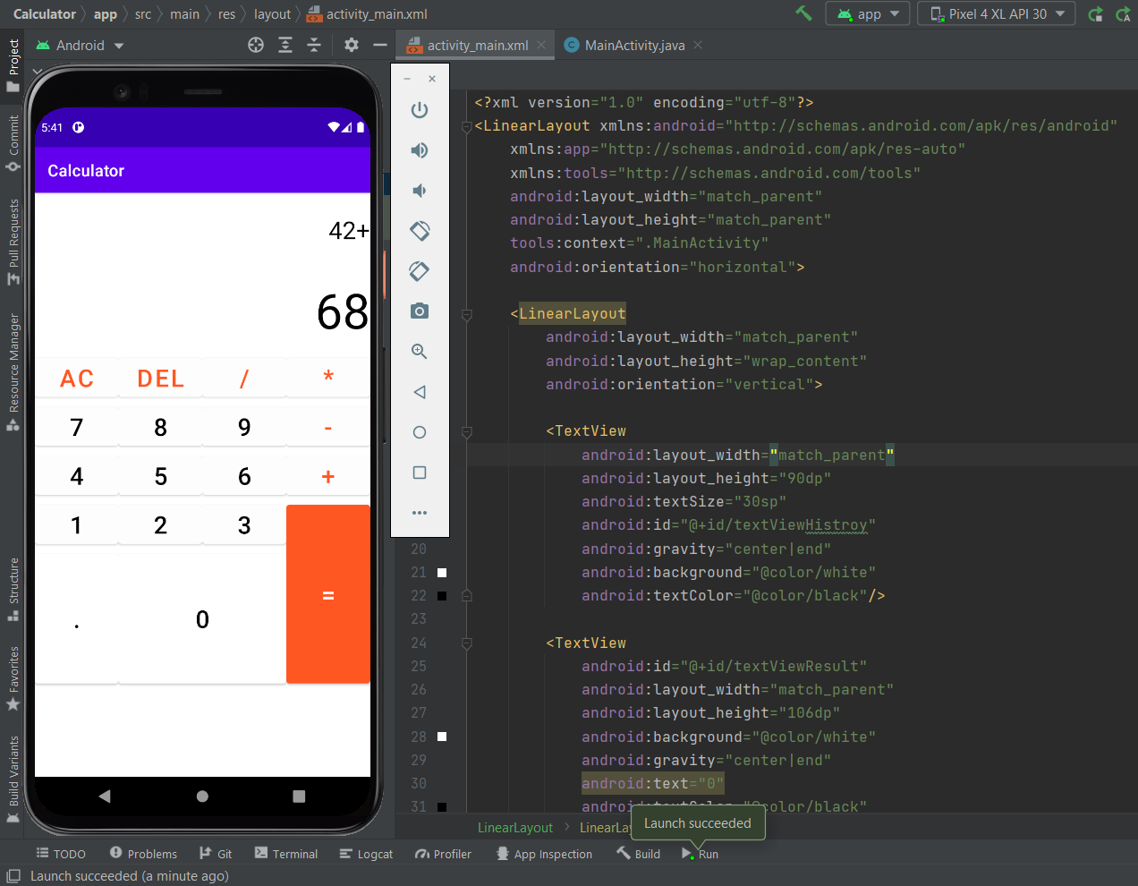

1. **Implement Intent project.**

**Activity_main.xml**

<?xml version="1.0" encoding="utf-8"?>

<androidx.constraintlayout.widget.ConstraintLayout

xmlns:android="http://schemas.android.com/apk/res/android"

xmlns:app="http://schemas.android.com/apk/res-auto"

xmlns:tools="http://schemas.android.com/tools"

android:layout_width="match_parent"

android:layout_height="match_parent"

tools:context=".MainActivity">

<EditText

android:id="@+id/editText"

android:layout_width="wrap_content"

android:layout_height="wrap_content"

android:layout_marginEnd="8dp"

android:layout_marginStart="8dp"

android:layout_marginTop="60dp"

android:ems="10"

app:layout_constraintEnd_toEndOf="parent"

app:layout_constraintHorizontal_bias="0.575"

app:layout_constraintStart_toStartOf="parent"

app:layout_constraintTop_toTopOf="parent" />

<Button

android:id="@+id/button"

android:layout_width="wrap_content"

android:layout_height="wrap_content"

android:layout_marginRight="8dp"

android:layout_marginLeft="156dp"

android:layout_marginTop="172dp"

android:text="Visit"

app:layout_constraintEnd_toEndOf="parent"

app:layout_constraintHorizontal_bias="0.0"

app:layout_constraintStart_toStartOf="parent"

app:layout_constraintTop_toBottomOf="@+id/editText" />

</androidx.constraintlayout.widget.ConstraintLayout>

**MainActivity.java**

package com.example.intent;

import androidx.appcompat.app.AppCompatActivity;

import android.content.Intent;

import android.net.Uri;

import android.os.Bundle;

import android.view.View;

import android.widget.Button;

import android.widget.EditText;

public class MainActivity extends AppCompatActivity {

Button button;

EditText editText;

@Override

protected void onCreate(Bundle savedInstanceState) {

super.onCreate(savedInstanceState);

setContentView(R.layout.activity_main);

button = findViewById(R.id.button);

editText = findViewById(R.id.editText);

button.setOnClickListener(new View.OnClickListener() {

@Override

public void onClick(View view) {

String url=editText.getText().toString();

Intent intent=new Intent(Intent.ACTION_VIEW, Uri.parse(url));

startActivity(intent);

}

});

}

}

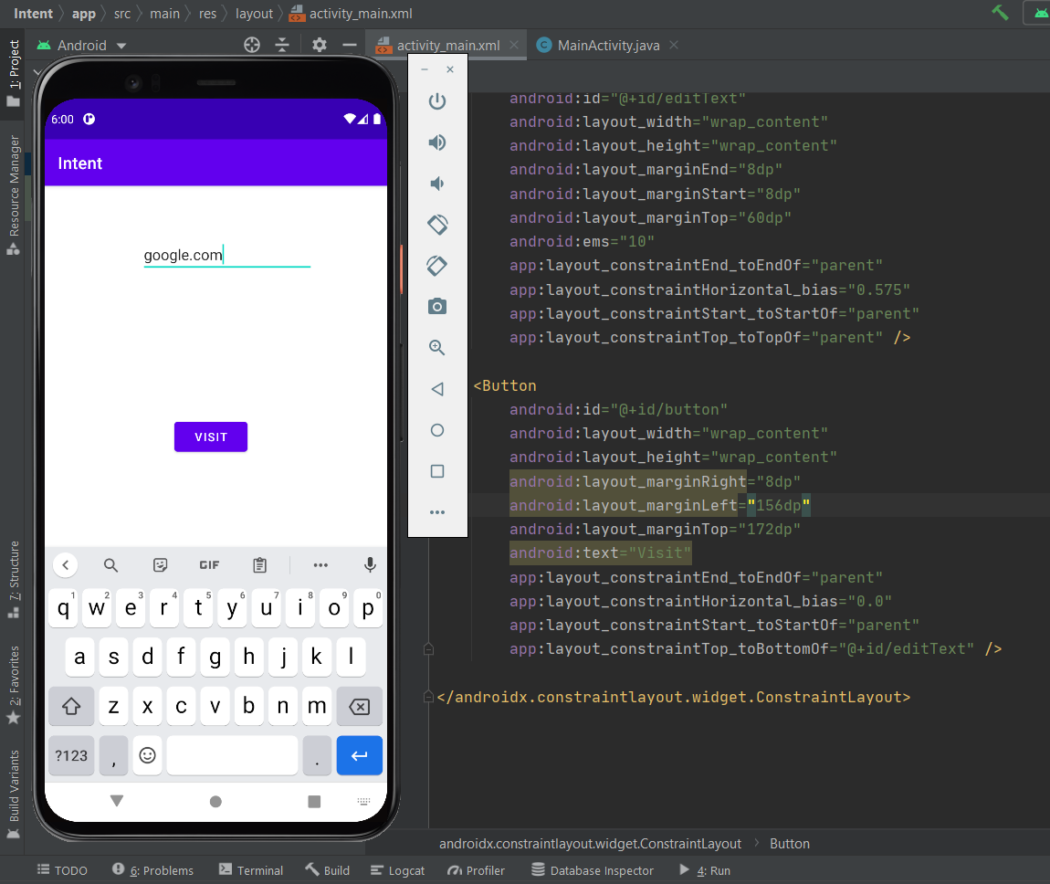

1. **Implement Math Game.**

**Activity_main.xml**

<?xml version="1.0" encoding="utf-8"?>

<LinearLayout xmlns:android="http://schemas.android.com/apk/res/android"

xmlns:app="http://schemas.android.com/apk/res-auto"

xmlns:tools="http://schemas.android.com/tools"

android:layout_width="match_parent"

android:layout_height="match_parent"

android:background="@drawable/first"

android:gravity="center_horizontal"

android:orientation="vertical"

tools:context=".MainActivity">

<Button

android:id="@+id/buttonAdd"

android:layout_width="200dp"

android:layout_height="75dp"

android:layout_marginTop="75dp"

android:text="Addition"

app:backgroundTint="@color/purple_200" />

<Button

android:id="@+id/buttonSub"

android:layout_width="200dp"

android:layout_height="75dp"

android:layout_marginTop="20dp"

android:text="substraction"

app:backgroundTint="@color/purple_200" />

<Button

android:id="@+id/buttonMul"

android:layout_width="200dp"

android:layout_height="75dp"

android:layout_marginTop="20dp"

android:text="multiplication"

app:backgroundTint="@color/purple_200" />

</LinearLayout>

**MainActivity.java**

package com.company.mathgame;

import androidx.appcompat.app.AppCompatActivity;

import android.content.Intent;

import android.os.Bundle;

import android.view.View;

import android.widget.Button;

public class MainActivity extends AppCompatActivity {

Button addition;

Button subtraction;

Button multi;

@Override

protected void onCreate(Bundle savedInstanceState) {

super.onCreate(savedInstanceState);

setContentView(R.layout.activity_main);

addition=findViewById(R.id.buttonAdd);

subtraction=findViewById(R.id.buttonSub);

multi=findViewById(R.id.buttonMul);

addition.setOnClickListener(new View.OnClickListener() {

@Override

public void onClick(View view) {//open second activity

Intent intent = new Intent(MainActivity.this,Game.class);

startActivity(intent);

}

});

}

}

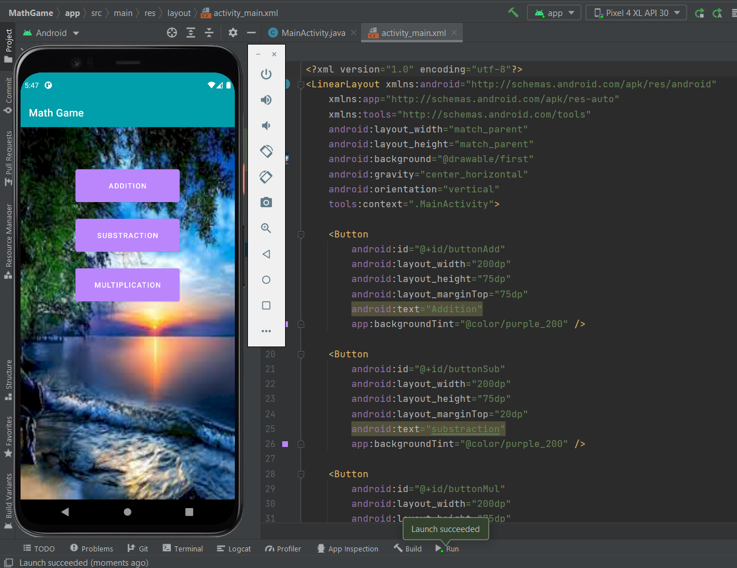

1. **Implement MP3 Player.**

**Activity_main.xml**

<?xml version="1.0" encoding="utf-8"?>

<androidx.constraintlayout.widget.ConstraintLayout xmlns:android="http://schemas.android.com/apk/res/android"

xmlns:app="http://schemas.android.com/apk/res-auto"

xmlns:tools="http://schemas.android.com/tools"

android:layout_width="match_parent"

android:layout_height="match_parent"

tools:context=".MainActivity">

<LinearLayout

android:id="@+id/linearLayout"

android:layout_width="match_parent"

android:layout_height="200dp"

android:background="@drawable/backround_card_view"

android:orientation="horizontal"

app:layout_constraintEnd_toEndOf="parent"

app:layout_constraintStart_toStartOf="parent"

app:layout_constraintTop_toTopOf="parent">

<ImageView

android:id="@+id/imageView"

android:layout_width="wrap_content"

android:layout_height="wrap_content"

android:layout_weight="1"

android:padding="20dp"

android:scaleType="fitCenter"

app:srcCompat="@drawable/note" />

</LinearLayout>

<androidx.recyclerview.widget.RecyclerView

android:id="@+id/recyclerView"

android:layout_width="match_parent"

android:layout_height="0dp"

app:layout_constraintBottom_toBottomOf="parent"

app:layout_constraintEnd_toEndOf="parent"

app:layout_constraintStart_toStartOf="parent"

app:layout_constraintTop_toBottomOf="@+id/linearLayout"

tools:listitem="@layout/card_music" />

</androidx.constraintlayout.widget.ConstraintLayout>

**MainActivity.java**

package com.company.mp3player;

import android.Manifest;

import android.content.pm.PackageManager;

import android.os.Bundle;

import android.os.Environment;

import android.util.Log;

import java.io.File;

import java.util.ArrayList;

public class MainActivity extends AppCompatActivity {

private RecyclerView recyclerView;

private final static String MEDIA_PATH = Environment.getExternalStorageDirectory().getPath()+"/";//need to access the main storage directory.

private ArrayList<String> songList = new ArrayList<>();

private MusicAdapter adapter;

@Override

protected void onCreate(Bundle savedInstanceState) {

super.onCreate(savedInstanceState);

setContentView(R.layout.activity_main);

Log.e("Media path",MEDIA_PATH);

recyclerView = findViewById(R.id.recyclerView);

recyclerView.setLayoutManager(new LinearLayoutManager(this));//using these method audio file sorted one by one

//recyclerView.setLayoutManager(new StaggeredGridLayoutManager(2,StaggeredGridLayoutManager.VERTICAL));

if (ContextCompat.checkSelfPermission(MainActivity.this, Manifest.permission.READ_EXTERNAL_STORAGE)//for the permission

!= PackageManager.PERMISSION_GRANTED)

{

ActivityCompat.requestPermissions(MainActivity.this

,new String[]{Manifest.permission.READ_EXTERNAL_STORAGE},1);

}

else

{

getAllAudioFiles();

}

}

public void getAllAudioFiles()//get all audio files method.

{

if (MEDIA_PATH != null)

{

File mainFile = new File(MEDIA_PATH);// media path object as the constructor

File[] fileList = mainFile.listFiles();

for (File file : fileList)

{

Log.e("Media path",file.toString());

if (file.isDirectory())

{

scanDirectory(file);

}

else

{

String path = file.getAbsolutePath();

if (path.endsWith(".mp3"))

{

songList.add(path);

adapter.notifyDataSetChanged();

}

}

}

}

adapter = new MusicAdapter(songList,MainActivity.this);

recyclerView.setAdapter(adapter);

}

public void scanDirectory(File directory)

{

if (directory != null)

{

File[] fileList = directory.listFiles();

for (File file : fileList)

{

Log.e("Media path",file.toString());

if (file.isDirectory())

{

scanDirectory(file);

}

else

{

String path = file.getAbsolutePath();

if (path.endsWith(".mp3"))

{

songList.add(path);

}

}

}

}

}

@Override

public void onRequestPermissionsResult(int requestCode, @NonNull String[] permissions, @NonNull int[] grantResults) {

super.onRequestPermissionsResult(requestCode, permissions, grantResults);

if (requestCode == 1 && grantResults.length > 0 && grantResults[0] == PackageManager.PERMISSION_GRANTED)

{

getAllAudioFiles();

}

}

}

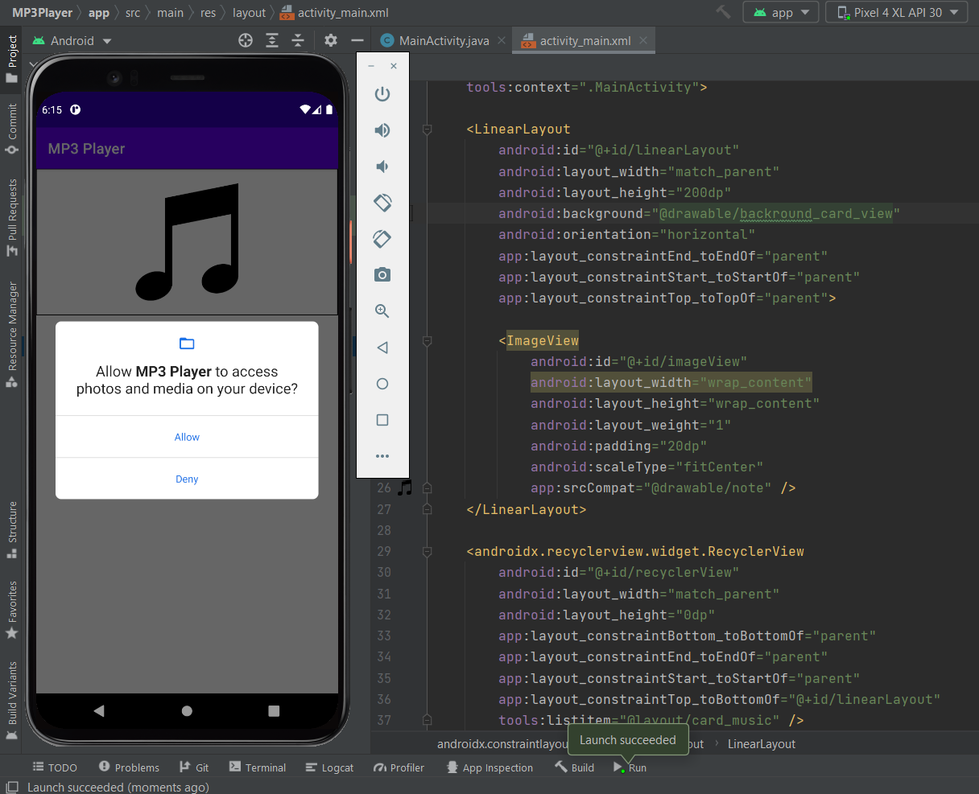

1. **Implement Note Take App.**

**Activity_main.xml**

<?xml version="1.0" encoding="utf-8"?>

<android.support.constraint.ConstraintLayout xmlns:android="http://schemas.android.com/apk/res/android"

xmlns:app="http://schemas.android.com/apk/res-auto"

xmlns:tools="http://schemas.android.com/tools"

android:id="@+id/layout_constraint"

android:layout_width="match_parent"

android:layout_height="match_parent"

tools:context="com.rafapps.simplenotes.SettingsActivity">

<LinearLayout

android:id="@+id/settingsLayout"

android:layout_width="match_parent"

android:layout_height="wrap_content"

android:divider="@drawable/divider_settings"

android:orientation="vertical"

android:showDividers="middle|end">

<LinearLayout

android:layout_width="match_parent"

android:layout_height="60dp"

android:gravity="center_vertical"

android:onClick="showPicker1"

android:orientation="horizontal"

android:paddingBottom="4dp"

android:paddingTop="8dp">

<ImageView

android:id="@+id/image_accent"

android:layout_width="40dp"

android:layout_height="40dp"

android:layout_margin="12dp"

android:background="@drawable/square"

android:contentDescription="@string/colour_indicator"

android:src="@drawable/ic_bg" />

<TextView

android:id="@+id/tv_accent"

android:layout_width="wrap_content"

android:layout_height="wrap_content"

android:layout_margin="8dp"

android:text="@string/accent_colour"

android:textSize="16sp" />

</LinearLayout>

<LinearLayout

android:layout_width="match_parent"

android:layout_height="60dp"

android:gravity="center_vertical"

android:onClick="showPicker2"

android:orientation="horizontal"

android:paddingBottom="4dp"

android:paddingTop="4dp">

<ImageView

android:id="@+id/image_font"

android:layout_width="40dp"

android:layout_height="40dp"

android:layout_margin="12dp"

android:background="@drawable/square"

android:contentDescription="@string/colour_indicator"

android:src="@drawable/ic_bg" />

<TextView

android:id="@+id/tv_font"

android:layout_width="wrap_content"

android:layout_height="wrap_content"

android:layout_margin="8dp"

android:text="@string/font_colour"

android:textSize="16sp" />

</LinearLayout>

<LinearLayout

android:layout_width="match_parent"

android:layout_height="60dp"

android:gravity="center_vertical"

android:onClick="toggleCheckBox"

android:orientation="horizontal"

android:paddingBottom="4dp"

android:paddingTop="4dp">

<CheckBox

android:id="@+id/checkbox_navigationbar"

android:layout_width="wrap_content"

android:layout_height="wrap_content"

android:layout_margin="16dp" />

<TextView

android:id="@+id/tv_navigationbar"

android:layout_width="wrap_content"

android:layout_height="wrap_content"

android:layout_margin="8dp"

android:text="@string/colour_navigation_bar"

android:textSize="16sp" />

</LinearLayout>

</LinearLayout>

<Button

android:id="@+id/btn_apply"

android:layout_width="150dp"

android:layout_height="wrap_content"

android:layout_marginBottom="7dp"

android:onClick="saveSettings"

android:text="@string/apply_changes"

android:textColor="@android:color/white"

app:layout_constraintBottom_toBottomOf="parent"

app:layout_constraintLeft_toLeftOf="parent"

app:layout_constraintRight_toRightOf="parent" />

<android.support.constraint.Guideline

android:id="@+id/guideline"

android:layout_width="wrap_content"

android:layout_height="wrap_content"

android:orientation="vertical"

app:layout_constraintGuide_begin="20dp" />

<android.support.constraint.Barrier

android:id="@+id/barrier2"

android:layout_width="wrap_content"

android:layout_height="wrap_content"

app:barrierDirection="top" />

</android.support.constraint.ConstraintLayout>

**Main_activity.java**

package com.rafapps.simplenotes;

import android.text.TextUtils;

import android.view.Menu;

import android.view.MenuItem;

import android.widget.EditText;

public class NoteActivity extends AppCompatActivity {

private static final String EXTRA_NOTE_TITLE = "EXTRA_NOTE_TITLE";

private boolean colourNavbar;

private String title, note;

private EditText noteText, titleText;

private AlertDialog dialog;

private @ColorInt

int colourPrimary, colourFont, colourBackground;

public static Intent getStartIntent(Context context, String title) {

Intent intent = new Intent(context, NoteActivity.class);

intent.putExtra(EXTRA_NOTE_TITLE, title);

return intent;

}

@Override

protected void onCreate(Bundle savedInstanceState) {

super.onCreate(savedInstanceState);

setContentView(R.layout.activity_note);

titleText = findViewById(R.id.et_title);

noteText = findViewById(R.id.et_note);

Intent intent = getIntent();

String action = intent.getAction();

String type = intent.getType();

// If activity started from a share intent

if (Intent.ACTION_SEND.equals(action) && type != null) {

if ("text/plain".equals(type)) {

String sharedText = intent.getStringExtra(Intent.EXTRA_TEXT);

noteText.setText(sharedText);

note = sharedText;

title = "";

}

} else { // If activity started from the notes list

title = intent.getStringExtra(EXTRA_NOTE_TITLE);

if (title == null || TextUtils.isEmpty(title)) {

title = "";

note = "";

noteText.requestFocus();

if (getSupportActionBar() != null)

getSupportActionBar().setTitle(getString(R.string.new_note));

} else {

titleText.setText(title);

note = HelperUtils.readFile(NoteActivity.this, title);

noteText.setText(note);

if (getSupportActionBar() != null)

getSupportActionBar().setTitle(title);

}

}

getSettings(PreferenceManager.getDefaultSharedPreferences(NoteActivity.this));

applySettings();

}

@Override

public void onRestart() {

super.onRestart();

note = noteText.getText().toString().trim();

if (getCurrentFocus() != null)

getCurrentFocus().clearFocus();

}

@Override

public void onPause() {

if (!isChangingConfigurations()) {

saveFile();

}

if (dialog != null && dialog.isShowing())

dialog.dismiss();

dialog = null;

super.onPause();

}

@Override

public void onBackPressed() {

super.onBackPressed();

}

@Override

public boolean onSupportNavigateUp() {

onBackPressed();

return true;

}

@Override

public boolean onCreateOptionsMenu(Menu menu) {

getMenuInflater().inflate(R.menu.menu_note, menu);

return true;

}

@Override

public boolean onOptionsItemSelected(MenuItem item) {

switch (item.getItemId()) {

case R.id.btn_undo:

noteText.setText(note);

noteText.setSelection(noteText.getText().length());

return (true);

case R.id.btn_share:

Intent sendIntent = new Intent();

sendIntent.setAction(Intent.ACTION_SEND);

sendIntent.putExtra(Intent.EXTRA_TEXT, noteText.getText().toString());

sendIntent.setType("text/plain");

startActivity(Intent.createChooser(sendIntent, getString(R.string.share_to)));

return (true);

case R.id.btn_delete:

dialog = new AlertDialog.Builder(NoteActivity.this, R.style.AlertDialogTheme)

.setTitle(getString(R.string.confirm_delete))

.setMessage(getString(R.string.confirm_delete_text))

.setPositiveButton(getString(R.string.yes), new DialogInterface.OnClickListener() {

public void onClick(DialogInterface dialog, int which) {

if (HelperUtils.fileExists(NoteActivity.this, title)) {

deleteFile(title + HelperUtils.TEXT_FILE_EXTENSION);

}

title = "";

note = "";

titleText.setText(title);

noteText.setText(note);

finish();

}

})

.setNegativeButton(getString(R.string.no), new DialogInterface.OnClickListener() {

public void onClick(DialogInterface dialog, int which) {

}

})

.setIcon(ContextCompat.getDrawable(getApplicationContext(), R.drawable.ic_delete_white_24dp))

.show();

if (dialog.getWindow() != null) {

dialog.getWindow().getDecorView().setBackgroundColor(colourPrimary);

}

dialog.getButton(DialogInterface.BUTTON_POSITIVE).setTextColor(Color.WHITE);

dialog.getButton(DialogInterface.BUTTON_NEGATIVE).setTextColor(Color.WHITE);

return (true);

}

return (super.onOptionsItemSelected(item));

}

private void getSettings(SharedPreferences preferences) {

colourPrimary = preferences.getInt(HelperUtils.PREFERENCE_COLOUR_PRIMARY, ContextCompat.getColor(NoteActivity.this, R.color.colorPrimary));

colourFont = preferences.getInt(HelperUtils.PREFERENCE_COLOUR_FONT, Color.BLACK);

colourBackground = preferences.getInt(HelperUtils.PREFERENCE_COLOUR_BACKGROUND, Color.WHITE);

colourNavbar = preferences.getBoolean(HelperUtils.PREFERENCE_COLOUR_NAVBAR, false);

}

private void applySettings() {

HelperUtils.applyColours(NoteActivity.this, colourPrimary, colourNavbar);

// Set text field underline colour

noteText.setBackgroundTintList(ColorStateList.valueOf(colourPrimary));

titleText.setBackgroundTintList(ColorStateList.valueOf(colourPrimary));

// Set actionbar and background colour

findViewById(R.id.scroll_view).setBackgroundColor(colourBackground);

if (getSupportActionBar() != null)

getSupportActionBar().setBackgroundDrawable(new ColorDrawable(colourPrimary));

// Set font colours

titleText.setTextColor(colourFont);

noteText.setTextColor(colourFont);

// Set hint colours

titleText.setHintTextColor(ColorUtils.setAlphaComponent(colourFont, 120));

noteText.setHintTextColor(ColorUtils.setAlphaComponent(colourFont, 120));

}

private void saveFile() {

// Get current title and note

String newTitle = titleText.getText().toString().trim().replace("/", " ");

String newNote = noteText.getText().toString().trim();

// Check if title and note are empty

if (TextUtils.isEmpty(newTitle) && TextUtils.isEmpty(newNote)) {

return;

}

// Check if title and note are unchanged

if (newTitle.equals(title) && newNote.equals(note)) {

return;

}

// Get file name to be saved if the title has changed or if it is empty

if (!title.equals(newTitle) || TextUtils.isEmpty(newTitle)) {

newTitle = newFileName(newTitle);

titleText.setText(newTitle);

}

// Save the file with the new file name and content

HelperUtils.writeFile(NoteActivity.this, newTitle, newNote);

// If the title is not empty and the file name has changed then delete the old file

if (!TextUtils.isEmpty(title) && !newTitle.equals(title)) {

deleteFile(title + HelperUtils.TEXT_FILE_EXTENSION);

}

// Set the title to be the new saved title for when the home button is pressed

title = newTitle;

}

private String newFileName(String name) {

// If it is empty, give it a default title of "Note"

if (TextUtils.isEmpty(name)) {

name = getString(R.string.note);

}

// If the name already exists, append a number to it

if (HelperUtils.fileExists(NoteActivity.this, name)) {

int i = 1;

while (true) {

if (!HelperUtils.fileExists(NoteActivity.this, name + " (" + i + ")") || title.equals(name + " (" + i + ")")) {

name = (name + " (" + i + ")");

break;

}

i++;

}

}

return name;

}

}

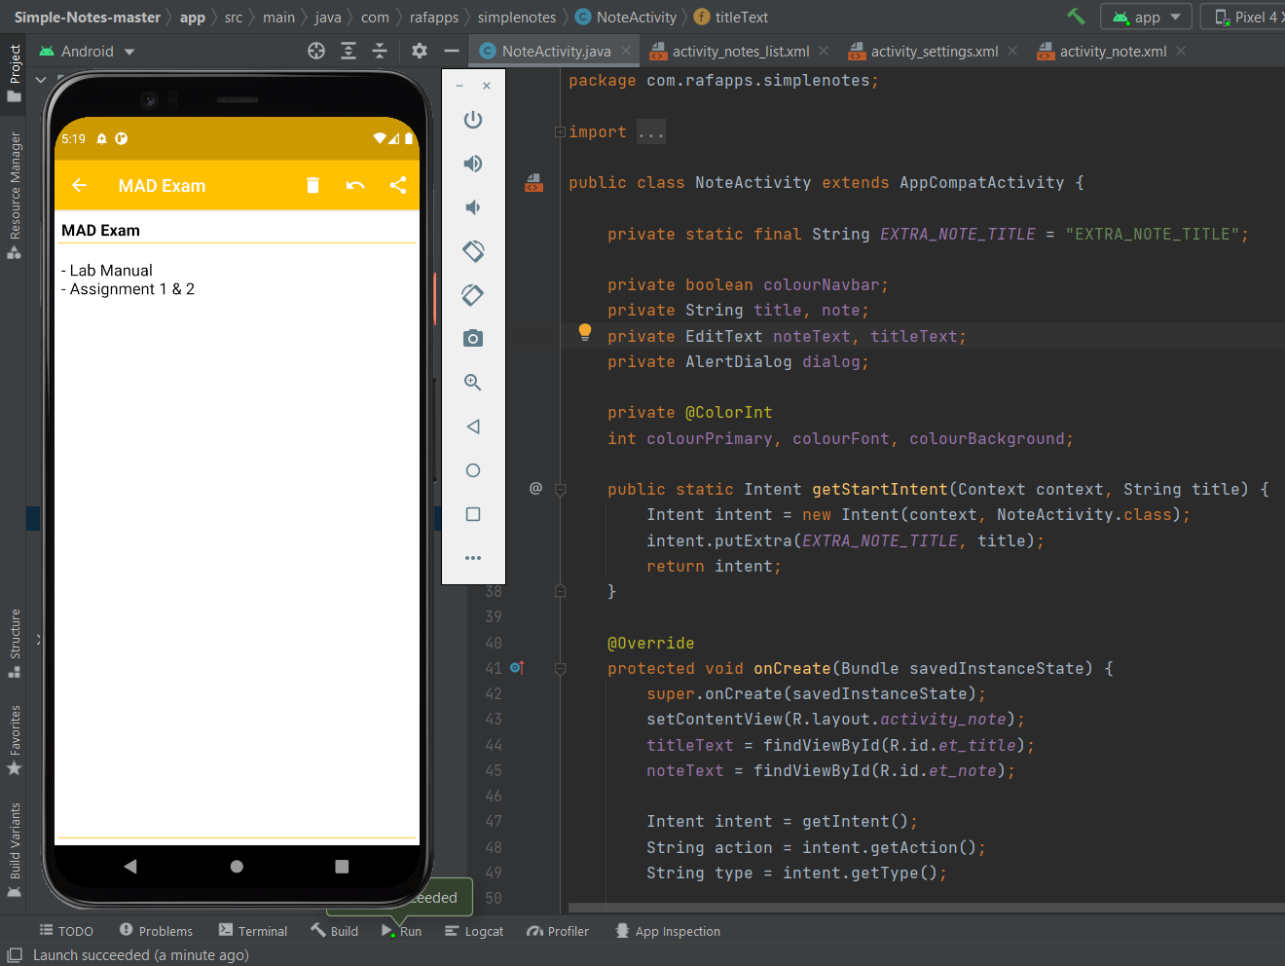

1. **Implement Number guessing game.**

**Activity_main.xml**

<?xml version="1.0" encoding="utf-8"?>

<androidx.constraintlayout.widget.ConstraintLayout xmlns:android="http://schemas.android.com/apk/res/android"

xmlns:app="http://schemas.android.com/apk/res-auto"

xmlns:tools="http://schemas.android.com/tools"

android:layout_width="match_parent"

android:layout_height="match_parent"

android:background="#A3E49898"

tools:context=".MainActivity">

<TextView

android:id="@+id/textView3"

android:layout_width="350dp"

android:layout_height="wrap_content"

android:layout_marginTop="50dp"

android:gravity="center"

android:text="@string/info"

android:textAlignment="center"

android:textAllCaps="false"

android:textColor="#000000"

android:textSize="24sp"

app:layout_constraintLeft_toLeftOf="parent"

app:layout_constraintRight_toRightOf="parent"

app:layout_constraintTop_toTopOf="parent" />

<RadioGroup

android:id="@+id/radioGroup"

android:layout_width="wrap_content"

android:layout_height="wrap_content"

android:layout_marginTop="50dp"

app:layout_constraintEnd_toEndOf="parent"

app:layout_constraintHorizontal_bias="0.5"

app:layout_constraintStart_toStartOf="parent"

app:layout_constraintTop_toBottomOf="@+id/textView3">

<RadioButton

android:id="@+id/radio2"

android:layout_width="match_parent"

android:layout_height="wrap_content"

android:layout_margin="10dp"

android:text="Two Digits Numbers"

android:textColor="#000000"

android:textSize="24sp"

android:textStyle="bold" />

<RadioButton

android:id="@+id/radio3"

android:layout_width="match_parent"

android:layout_height="wrap_content"

android:layout_margin="10dp"

android:text="Three Digits Numbers"

android:textColor="#000000"

android:textSize="24sp"

android:textStyle="bold" />

<RadioButton

android:id="@+id/radio4"

android:layout_width="match_parent"

android:layout_height="wrap_content"

android:layout_margin="10dp"

android:text="Four Digits Numbers"

android:textSize="24sp"

android:textStyle="bold" />

</RadioGroup>

<Button

android:id="@+id/buttonStart"

android:layout_width="350dp"

android:layout_height="wrap_content"

android:layout_marginTop="46dp"

android:text="Start"

app:backgroundTint="#E64A19"

app:layout_constraintEnd_toEndOf="parent"

app:layout_constraintHorizontal_bias="0.5"

app:layout_constraintStart_toStartOf="parent"

app:layout_constraintTop_toBottomOf="@+id/radioGroup" />

</androidx.constraintlayout.widget.ConstraintLayout>

**MainActivity.java**

package com.company.numberguessinggame;

import androidx.appcompat.app.AppCompatActivity;

import com.google.android.material.snackbar.Snackbar;

public class MainActivity extends AppCompatActivity {

private Button buttonStart;

private RadioButton radio2,radio3,radio4;

@Override

protected void onCreate(Bundle savedInstanceState) {

super.onCreate(savedInstanceState);

setContentView(R.layout.activity_main);

buttonStart=findViewById(R.id.buttonStart);

radio2=findViewById(R.id.radio2);

radio3=findViewById(R.id.radio3);

radio4=findViewById(R.id.radio4);

buttonStart.setOnClickListener(new View.OnClickListener() {

@Override

public void onClick(View view) {

Intent intent = new Intent(MainActivity.this,GameActivity.class);

if (!radio2.isChecked() && !radio3.isChecked() && !radio4.isChecked())

{

Snackbar.make(view,"Please select a number of digits",Snackbar.LENGTH_LONG).show();

}

else

{

if(radio2.isChecked())

{

intent.putExtra("two",true);

}

if(radio3.isChecked())

{

intent.putExtra("three",true);

}

if(radio4.isChecked())

{

intent.putExtra("four",true);

}

startActivity(intent);

}

}

});

}

}

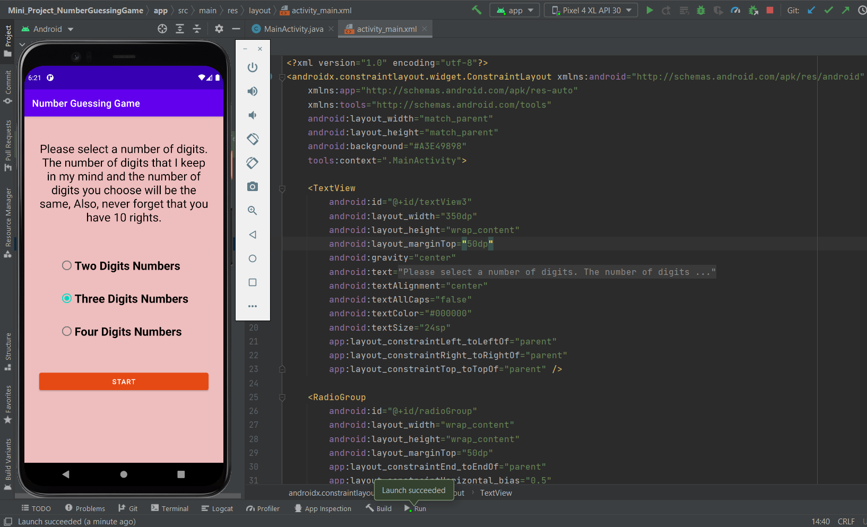

1. **Implement online examination system.**

**Activity_main.xml**

<?xml version="1.0" encoding="utf-8"?>

<androidx.constraintlayout.widget.ConstraintLayout xmlns:android="http://schemas.android.com/apk/res/android"

xmlns:app="http://schemas.android.com/apk/res-auto"

xmlns:tools="http://schemas.android.com/tools"

android:layout_width="match_parent"

android:layout_height="match_parent"

tools:context="com.corp.srihari.deca.LoginActivity"

tools:layout_editor_absoluteY="81dp"

tools:layout_editor_absoluteX="0dp"

android:background="@drawable/background">

<EditText

android:id="@+id/login_email_edit"

android:layout_width="307dp"

android:layout_height="wrap_content"

android:layout_marginLeft="8dp"

android:layout_marginTop="8dp"

android:layout_marginRight="8dp"

android:background="@drawable/rectangle_border"

android:ems="10"

android:hint="Email"

android:inputType="textEmailAddress"

android:padding="10dp"

android:textColor="@color/white"

android:textColorHint="@color/white"

app:layout_constraintBottom_toTopOf="@+id/login_password_edit"

app:layout_constraintHorizontal_bias="0.511"

app:layout_constraintLeft_toLeftOf="parent"

app:layout_constraintRight_toRightOf="parent"

app:layout_constraintTop_toBottomOf="@+id/login_logo"

app:layout_constraintVertical_bias="0.884" />

<EditText

android:id="@+id/login_password_edit"

android:layout_width="307dp"

android:layout_height="wrap_content"

android:layout_marginLeft="8dp"

android:layout_marginRight="8dp"

android:layout_marginBottom="40dp"

android:background="@drawable/rectangle_border"

android:ems="10"

android:hint="Password"

android:inputType="textPassword"

android:padding="10dp"

android:textColor="@color/white"

android:textColorHint="@color/white"

app:layout_constraintBottom_toTopOf="@+id/login_button"

app:layout_constraintHorizontal_bias="0.511"

app:layout_constraintLeft_toLeftOf="parent"

app:layout_constraintRight_toRightOf="parent" />

<ImageView

android:id="@+id/login_logo"

android:layout_width="410dp"

android:layout_height="194dp"

android:layout_marginLeft="8dp"

android:layout_marginRight="8dp"

android:layout_marginTop="41dp"

android:scaleType="fitCenter"

android:src="@drawable/easy_exams_logo_white"

android:visibility="visible"

app:layout_constraintHorizontal_bias="0.517"

app:layout_constraintLeft_toLeftOf="parent"

app:layout_constraintRight_toRightOf="parent"

app:layout_constraintTop_toTopOf="parent" />

<ImageButton

android:id="@+id/login_button"

style="@style/Widget.AppCompat.ImageButton"

android:layout_width="273dp"

android:layout_height="59dp"

android:layout_marginLeft="8dp"

android:layout_marginTop="8dp"

android:layout_marginRight="8dp"

android:layout_marginBottom="8dp"

android:background="#00000000"

android:scaleType="fitXY"

android:src="@drawable/login_login"

app:layout_constraintBottom_toBottomOf="parent"

app:layout_constraintHorizontal_bias="0.495"

app:layout_constraintLeft_toLeftOf="parent"

app:layout_constraintRight_toRightOf="parent"

app:layout_constraintTop_toTopOf="parent"

app:layout_constraintVertical_bias="0.725" />

<ImageButton

android:id="@+id/sign_up_button"

android:layout_width="272dp"

android:layout_height="54dp"

android:layout_marginStart="8dp"

android:layout_marginTop="8dp"

android:layout_marginEnd="8dp"

android:layout_marginBottom="32dp"

android:background="#00000000"

android:scaleType="fitXY"

android:src="@drawable/login_signup"

app:layout_constraintBottom_toBottomOf="parent"

app:layout_constraintEnd_toEndOf="parent"

app:layout_constraintHorizontal_bias="0.495"

app:layout_constraintRight_toRightOf="parent"

app:layout_constraintStart_toStartOf="parent"

app:layout_constraintTop_toBottomOf="@+id/login_button"

app:layout_constraintVertical_bias="0.062" />

<Button

android:id="@+id/forgotPassword"

style="@style/Widget.AppCompat.Button.Borderless"

android:layout_width="190dp"

android:layout_height="37dp"

android:layout_marginStart="8dp"

android:layout_marginEnd="8dp"

android:layout_marginBottom="8dp"

android:text="Forgot your password?"

android:textAppearance="@style/TextAppearance.AppCompat.Body2"

android:textColor="#3579A6"

app:layout_constraintBottom_toBottomOf="parent"

app:layout_constraintEnd_toEndOf="parent"

app:layout_constraintStart_toStartOf="parent" />

<ProgressBar

android:id="@+id/loginloading"

style="?android:attr/progressBarStyle"

android:layout_width="wrap_content"

android:layout_height="wrap_content"

android:layout_marginBottom="8dp"

android:layout_marginLeft="8dp"

android:layout_marginRight="8dp"

android:layout_marginTop="8dp"

android:visibility="gone"

app:layout_constraintBottom_toBottomOf="parent"

app:layout_constraintLeft_toLeftOf="parent"

app:layout_constraintRight_toRightOf="parent"

app:layout_constraintTop_toTopOf="parent" />

</androidx.constraintlayout.widget.ConstraintLayout>

**MainActivity.java**

package com.corp.srihari.deca;

import android.os.Bundle;

import android.view.MenuItem;

import androidx.annotation.NonNull;

import androidx.appcompat.app.AppCompatActivity;

import androidx.fragment.app.Fragment;

import androidx.fragment.app.FragmentTransaction;

import com.google.android.material.bottomnavigation.BottomNavigationView;

public class MainActivity extends AppCompatActivity {

private BottomNavigationView navigation;

private BottomNavigationView.OnNavigationItemSelectedListener mOnNavigationItemSelectedListener

= new BottomNavigationView.OnNavigationItemSelectedListener() {

@Override

public boolean onNavigationItemSelected(@NonNull MenuItem item) {

Fragment selectedFragment = null;

switch (item.getItemId()) {

case R.id.navigation_home:

selectedFragment = HomeFragment.newInstance();

break;

case R.id.navigation_resources:

selectedFragment = ResourcesFragment.newInstance();

break;

case R.id.navigation_profile:

selectedFragment = ProfileFragment.newInstance();

break;

}

FragmentTransaction transaction = getSupportFragmentManager().beginTransaction();

transaction.replace(R.id.frame_layout, selectedFragment);

transaction.commit();

return true;

}

};

@Override

protected void onCreate(Bundle savedInstanceState) {

super.onCreate(savedInstanceState);

setContentView(R.layout.activity_main);

BottomNavigationView navigation = (BottomNavigationView) findViewById(R.id.navigation);

navigation.setOnNavigationItemSelectedListener(mOnNavigationItemSelectedListener);

navigation.setSelectedItemId(R.id.navigation_home);

}

}

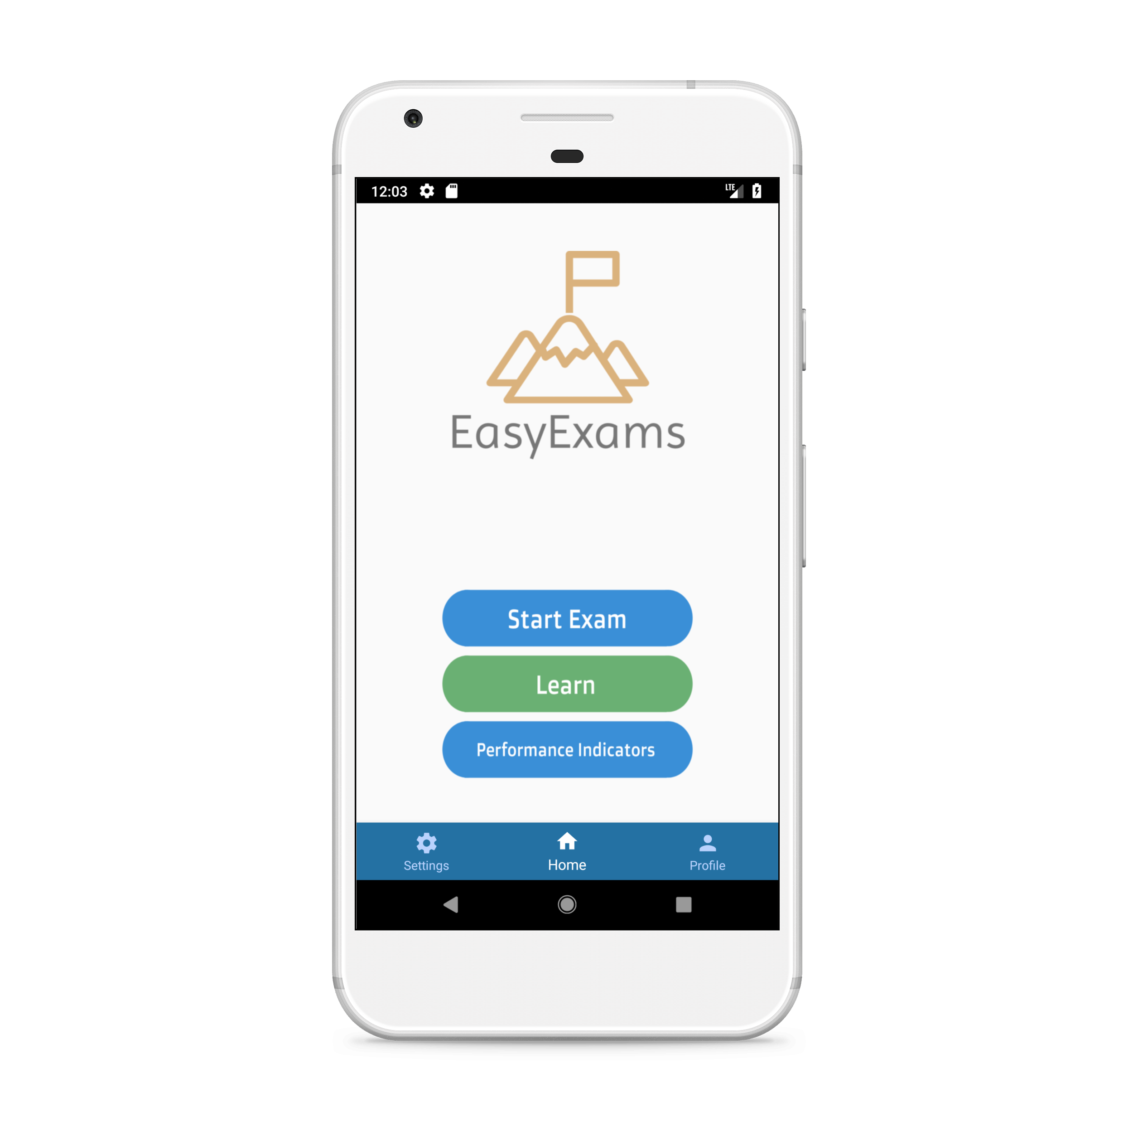

1. **Implement periodic notification.**

**Activity_main.xml**

<?xml version="1.0" encoding="utf-8"?>

<androidx.constraintlayout.widget.ConstraintLayout xmlns:android="http://schemas.android.com/apk/res/android"

xmlns:app="http://schemas.android.com/apk/res-auto"

xmlns:tools="http://schemas.android.com/tools"

android:layout_width="match_parent"

android:layout_height="match_parent"

tools:context=".MainActivity">

<Button

android:id="@+id/button"

android:layout_width="wrap_content"

android:layout_height="wrap_content"

android:text="Button"

android:textSize="24sp"

app:layout_constraintBottom_toBottomOf="parent"

app:layout_constraintEnd_toEndOf="parent"

app:layout_constraintHorizontal_bias="0.5"

app:layout_constraintStart_toStartOf="parent"

app:layout_constraintTop_toTopOf="parent" />

</androidx.constraintlayout.widget.ConstraintLayout>

**MainActivity.java**

package com.company.localnotification;

import androidx.appcompat.app.AppCompatActivity;

import androidx.core.app.NotificationManagerCompat;

import java.util.Calendar;

public class MainActivity extends AppCompatActivity {

Button button;

@Override

protected void onCreate(Bundle savedInstanceState) {

super.onCreate(savedInstanceState);

setContentView(R.layout.activity_main);

button = findViewById(R.id.button);

button.setOnClickListener(new View.OnClickListener() {

@Override

public void onClick(View view) {

Calendar calendar = Calendar.getInstance();//inbuilt class

calendar.set(calendar.HOUR_OF_DAY,8);

calendar.set(calendar.MINUTE,40);

calendar.set(Calendar.SECOND,0);

Intent i = new Intent(getApplicationContext(),Notification_Receiver.class);

PendingIntent pendingIntent = PendingIntent.getBroadcast(getApplicationContext(),100,i

,PendingIntent.FLAG_UPDATE_CURRENT);

AlarmManager alarmManager = (AlarmManager)getSystemService(ALARM_SERVICE);//message is received in broadcast class

alarmManager.setRepeating(AlarmManager.RTC_WAKEUP,calendar.getTimeInMillis(),

AlarmManager.INTERVAL_DAY,pendingIntent);

}

});

}

}

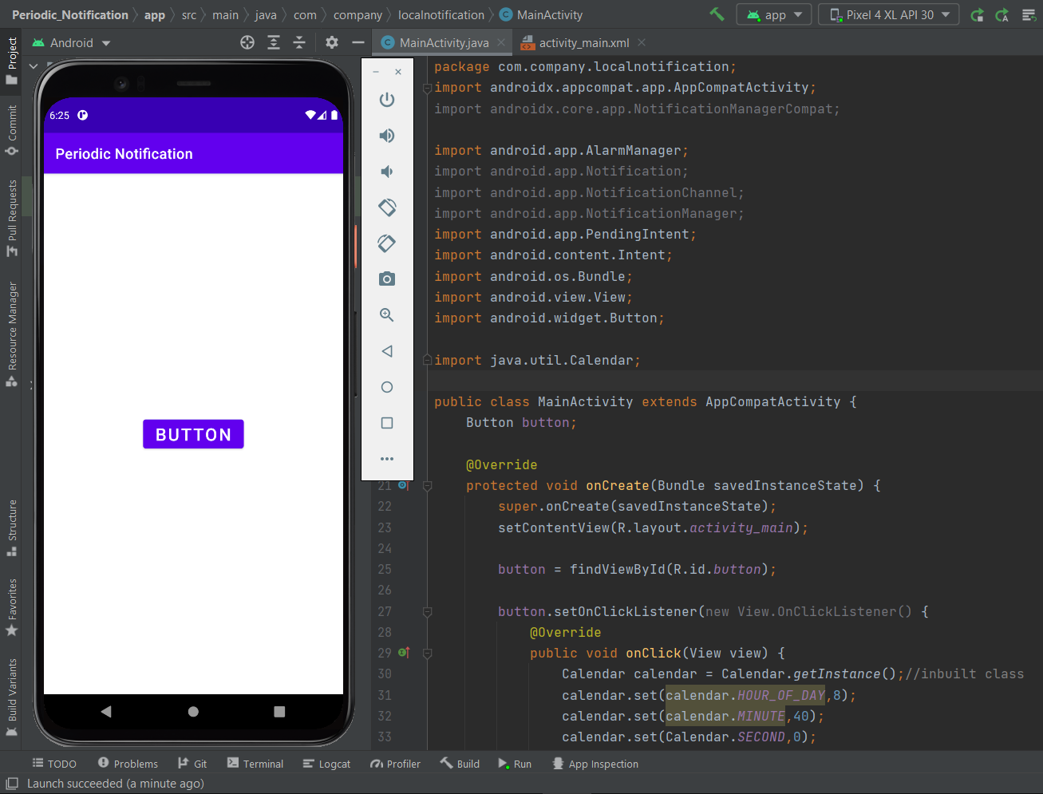

1. **Implement phone call app.**

**Activity_main.xml**

<?xml version="1.0" encoding="utf-8"?>

<androidx.constraintlayout.widget.ConstraintLayout xmlns:android="http://schemas.android.com/apk/res/android"

xmlns:app="http://schemas.android.com/apk/res-auto"

xmlns:tools="http://schemas.android.com/tools"

android:layout_width="match_parent"

android:layout_height="match_parent"

tools:context=".MainActivity">

<EditText

android:id="@+id/editTextPhoneNumber"

android:layout_width="300dp"

android:layout_height="wrap_content"

android:ems="10"

android:hint="Enter Phone Number"

android:inputType="number"

app:layout_constraintBottom_toTopOf="@+id/buttonsend"

app:layout_constraintEnd_toEndOf="parent"

app:layout_constraintHorizontal_bias="0.5"

app:layout_constraintStart_toStartOf="parent"

app:layout_constraintTop_toTopOf="parent" />

<Button

android:id="@+id/buttonsend"

android:layout_width="250dp"

android:layout_height="wrap_content"

android:text="Call Number"

app:layout_constraintBottom_toBottomOf="parent"

app:layout_constraintEnd_toEndOf="parent"

app:layout_constraintHorizontal_bias="0.498"

app:layout_constraintStart_toStartOf="parent"

app:layout_constraintTop_toBottomOf="@+id/editTextPhoneNumber" />

</androidx.constraintlayout.widget.ConstraintLayout>

**MainActivity.java**

package com.company.phonecall;

import android.os.Bundle;

import android.view.View;

import android.widget.Button;

import android.widget.EditText;

public class MainActivity extends AppCompatActivity {

Button call;

EditText number;

String userNumber;

@Override

protected void onCreate(Bundle savedInstanceState) {

super.onCreate(savedInstanceState);

setContentView(R.layout.activity_main);

call=findViewById(R.id.buttonsend);

number=findViewById(R.id.editTextPhoneNumber);

call.setOnClickListener(new View.OnClickListener() {

@Override

public void onClick(View view) {

userNumber = number.getText().toString();

phoneCall(userNumber);

}

});

}

public void phoneCall(String userNumber)

{

if(ContextCompat.checkSelfPermission(MainActivity.this, Manifest.permission.CALL_PHONE)

!= PackageManager.PERMISSION_GRANTED)

{

ActivityCompat.requestPermissions(MainActivity.this

,new String[]{Manifest.permission.CALL_PHONE},100);

}

else

{

Intent intent = new Intent(Intent.ACTION_CALL);

intent.setData(Uri.parse("tel:"+ userNumber));

startActivity(intent);

}

}

@Override

public void onRequestPermissionsResult(int requestCode, @NonNull String[] permissions, @NonNull int[] grantResults) {

super.onRequestPermissionsResult(requestCode, permissions, grantResults);

if(requestCode == 100 && grantResults.length > 0 && grantResults[0]== PackageManager.PERMISSION_GRANTED)

{

Intent intent = new Intent(Intent.ACTION_CALL);

intent.setData(Uri.parse("tel:"+ userNumber));

startActivity(intent);

}

}

}

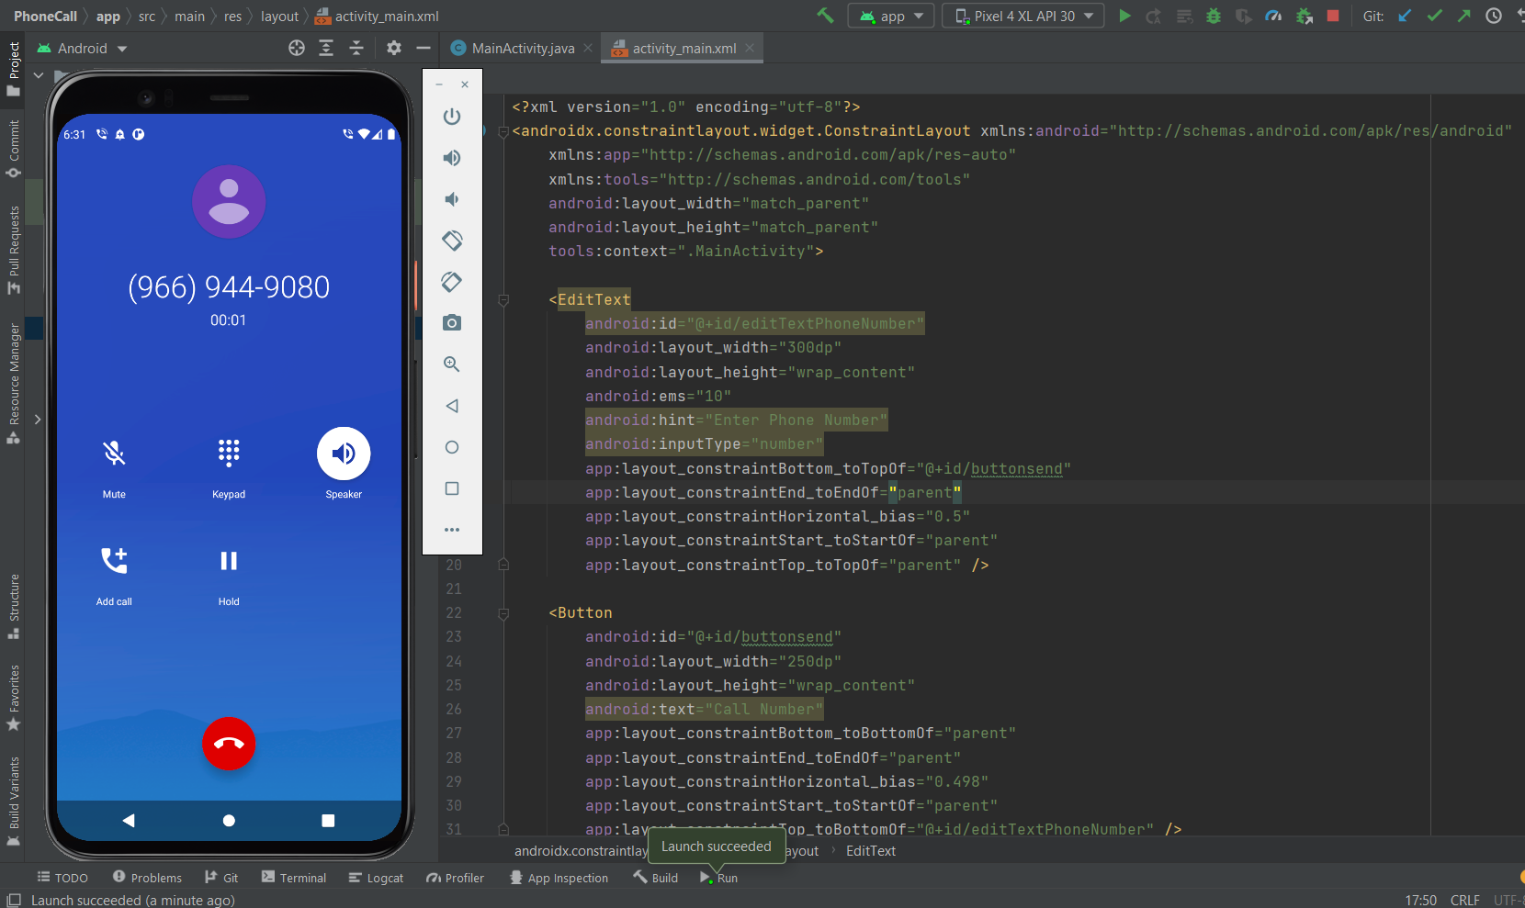

1. **Implement Speech to text app.**

**Activity_main.xml**

<?xml version="1.0" encoding="utf-8"?>

<androidx.constraintlayout.widget.ConstraintLayout xmlns:android="http://schemas.android.com/apk/res/android"

xmlns:app="http://schemas.android.com/apk/res-auto"

xmlns:tools="http://schemas.android.com/tools"

android:layout_width="match_parent"

android:layout_height="match_parent"

tools:context=".MainActivity">

<TextView

android:id="@+id/textView2"

android:layout_width="wrap_content"

android:layout_height="wrap_content"

android:layout_marginTop="129dp"

android:layout_marginBottom="82dp"

android:text="Press to microphone to speak"

android:textSize="24sp"

app:layout_constraintBottom_toTopOf="@+id/imageButton"

app:layout_constraintEnd_toEndOf="parent"

app:layout_constraintStart_toStartOf="parent"

app:layout_constraintTop_toTopOf="parent"

app:layout_constraintVertical_bias="0.184" />

<ImageButton

android:id="@+id/imageButton"

android:layout_width="150dp"

android:layout_height="0dp"

android:layout_marginBottom="338dp"

android:scaleType="fitCenter"

app:layout_constraintBottom_toBottomOf="parent"

app:layout_constraintEnd_toEndOf="parent"

app:layout_constraintStart_toStartOf="parent"

app:layout_constraintTop_toBottomOf="@+id/textView2"

app:srcCompat="@drawable/ic_baseline_mic_24" />

</androidx.constraintlayout.widget.ConstraintLayout>

**MainActivity.java**

package com.company.speechtotext;

import androidx.annotation.Nullable;

import androidx.appcompat.app.AppCompatActivity;

import android.view.View;

import android.widget.ImageButton;

import android.widget.TextView;

import java.util.ArrayList;

import java.util.Locale;

public class MainActivity extends AppCompatActivity {

TextView result;

ImageButton mic;

@Override

protected void onCreate(Bundle savedInstanceState) {

super.onCreate(savedInstanceState);

setContentView(R.layout.activity_main);

result=findViewById(R.id.textView2);

mic=findViewById(R.id.imageButton);

mic.setOnClickListener(new View.OnClickListener() {

@Override

public void onClick(View view) {

convertSpeech();

}

});

}

public void convertSpeech()

{

Intent intent = new Intent(RecognizerIntent.ACTION_RECOGNIZE_SPEECH);

intent.putExtra(RecognizerIntent.EXTRA_LANGUAGE_MODEL,RecognizerIntent.LANGUAGE_MODEL_FREE_FORM);

intent.putExtra(RecognizerIntent.EXTRA_LANGUAGE, Locale.getDefault());

startActivityForResult(intent,1);

}

@Override

protected void onActivityResult(int requestCode, int resultCode, @Nullable Intent data) {

super.onActivityResult(requestCode, resultCode, data);

if(requestCode == 1 && resultCode == RESULT_OK)

{

ArrayList<String> speakResults = data.getStringArrayListExtra(RecognizerIntent.EXTRA_RESULTS);

result.setText(speakResults.get(0));

}

}

}

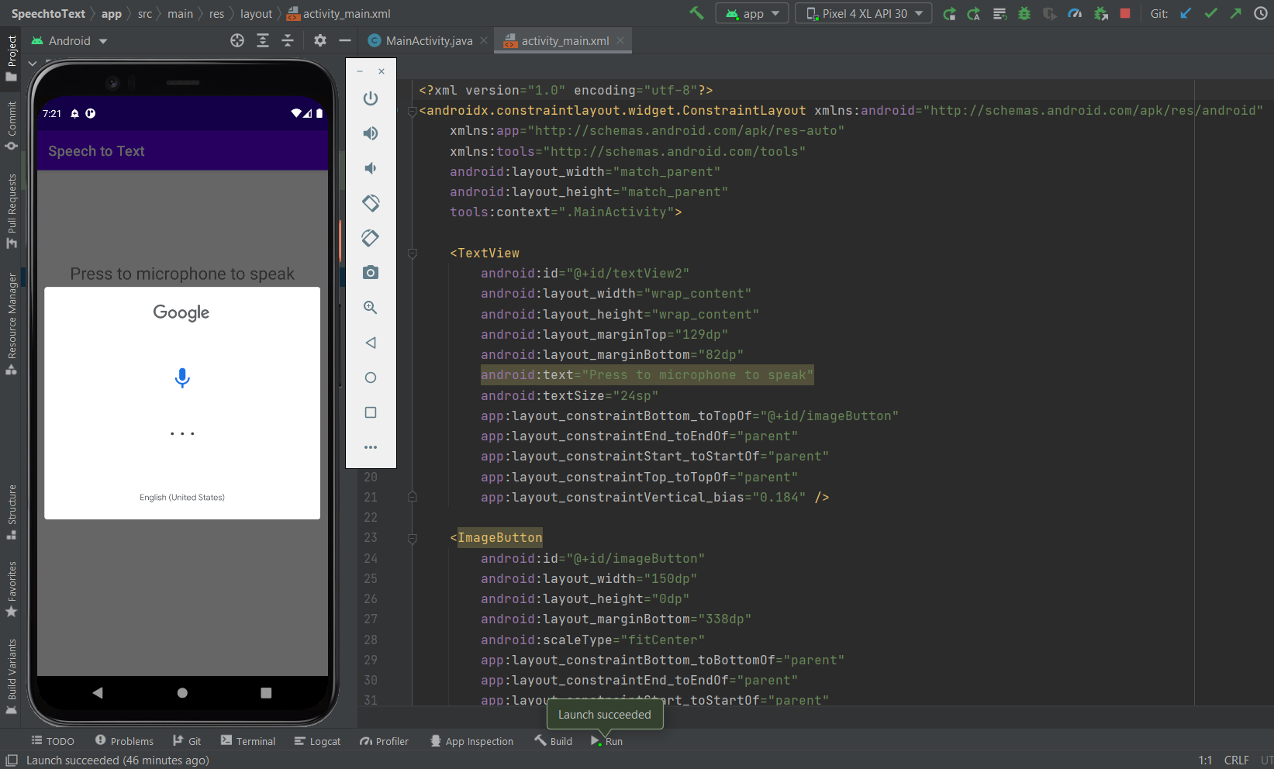

1. **Implement Weather app.**

**Activity_main.xml**

<?xml version="1.0" encoding="utf-8"?>

<LinearLayout

xmlns:android="http://schemas.android.com/apk/res/android"

xmlns:app="http://schemas.android.com/apk/res-auto"

xmlns:tools="http://schemas.android.com/tools"

android:layout_width="match_parent"

android:layout_height="match_parent"

tools:context=".MainActivity"

android:orientation="vertical"

android:background="#1E90FF"

android:id="@+id/linear_layout">

<TextView

android:layout_width="wrap_content"

android:layout_height="wrap_content"

android:id="@+id/textViewCity"

android:layout_gravity="center"

android:layout_margin="7dp"

android:text="London , GB"

android:textSize="30sp"

android:textColor="#FFFFFF"/>

<LinearLayout

android:layout_width="match_parent"

android:layout_height="wrap_content"

android:orientation="horizontal"

android:layout_marginTop="3dp">

<ImageView

android:id="@+id/imageView"

android:layout_width="100dp"

android:layout_height="100dp"

android:layout_marginStart="25dp"

android:scaleType="fitXY"

android:src="@drawable/ic_launcher_background"/>

<LinearLayout

android:layout_width="wrap_content"

android:layout_height="wrap_content"

android:orientation="vertical"

android:layout_marginStart="10dp">

<TextView

android:layout_width="wrap_content"

android:layout_height="wrap_content"

android:id="@+id/textViewTemp"

android:text="25 C"

android:textSize="50sp"

android:textColor="#FFFFFF"

android:layout_gravity="center"/>

<TextView

android:layout_width="wrap_content"

android:layout_height="wrap_content"

android:id="@+id/textViewWeatherCondition"

android:text="Few Clouds"

android:textSize="30sp"

android:textColor="#FFFFFF"

android:textAlignment="center"/>

</LinearLayout>

</LinearLayout>

<TextView

android:layout_width="match_parent"

android:layout_height="wrap_content"

android:text="Details :"

android:textSize="30sp"

android:textColor="#FFFFFF"

android:layout_marginStart="25dp"

android:layout_marginBottom="10dp"/>

<LinearLayout

android:layout_width="match_parent"

android:layout_height="wrap_content"

android:orientation="horizontal">

<LinearLayout

android:layout_width="wrap_content"

android:layout_height="wrap_content"

android:orientation="vertical"

android:layout_marginStart="10dp"

android:layout_marginTop="5dp">

<TextView

android:id="@+id/textViewHumidity"

android:layout_width="wrap_content"

android:layout_height="wrap_content"

android:text=": 50%"

android:textColor="#FFFFFF"

android:textSize="24sp"

android:layout_marginTop="5dp"/>

<TextView

android:id="@+id/textViewMaxTemp"

android:layout_width="wrap_content"

android:layout_height="wrap_content"

android:text=": 25 C"

android:textColor="#FFFFFF"

android:textSize="24sp"

android:layout_marginTop="5dp"/>

<TextView

android:id="@+id/textViewMinTemp"

android:layout_width="wrap_content"

android:layout_height="wrap_content"

android:text=": 25 C"

android:textColor="#FFFFFF"

android:textSize="24sp"

android:layout_marginTop="5dp"/>

<TextView

android:id="@+id/textViewPressure"

android:layout_width="wrap_content"

android:layout_height="wrap_content"

android:text=": 50"

android:textColor="#FFFFFF"

android:textSize="24sp"

android:layout_marginTop="5dp"/>

<TextView

android:id="@+id/textViewWind"

android:layout_width="wrap_content"

android:layout_height="wrap_content"

android:text=": 5"

android:textColor="#FFFFFF"

android:textSize="24sp"

android:layout_marginTop="5dp"/>

</LinearLayout>

</LinearLayout>

<androidx.constraintlayout.widget.ConstraintLayout

android:layout_width="match_parent"

android:layout_height="match_parent">

<com.google.android.material.floatingactionbutton.FloatingActionButton

android:id="@+id/fab"

android:layout_width="wrap_content"

android:layout_height="wrap_content"

android:layout_marginEnd="20dp"

android:layout_marginBottom="20dp"

android:clickable="true"

app:layout_constraintBottom_toBottomOf="parent"

app:layout_constraintEnd_toEndOf="parent"

app:srcCompat="@drawable/add"

android:layout_marginRight="20dp"

tools:ignore="VectorDrawableCompat" />

</androidx.constraintlayout.widget.ConstraintLayout>

</LinearLayout>

**MainActivity.java**

package com.company.weatherapp;

import androidx.annotation.NonNull;

import androidx.appcompat.app.AppCompatActivity;

import androidx.core.app.ActivityCompat;

import androidx.core.content.ContextCompat;

import retrofit2.Call;

import retrofit2.Callback;

import retrofit2.Response;

public class MainActivity extends AppCompatActivity {

private TextView city,temperature,weatherCondition,humidity,maxTemperature,minTemperature,pressure,wind;

private ImageView imageView;

private FloatingActionButton fab;

LocationManager locationManager;

LocationListener locationListener;

double lat,lon;

@Override

protected void onCreate(Bundle savedInstanceState) {

super.onCreate(savedInstanceState);

setContentView(R.layout.activity_main);

city = findViewById(R.id.textViewCity);

temperature = findViewById(R.id.textViewTemp);

weatherCondition = findViewById(R.id.textViewWeatherCondition);

humidity = findViewById(R.id.textViewHumidity);

maxTemperature = findViewById(R.id.textViewMaxTemp);

minTemperature = findViewById(R.id.textViewMinTemp);

pressure = findViewById(R.id.textViewPressure);

wind = findViewById(R.id.textViewWind);

imageView = findViewById(R.id.imageView);

fab = findViewById(R.id.fab);

fab.setOnClickListener(new View.OnClickListener() {

@Override

public void onClick(View v) {

Intent intent = new Intent(MainActivity.this,WeatherActivity.class);

startActivity(intent);

}

});

locationManager = (LocationManager)getSystemService(Context.LOCATION_SERVICE);

locationListener = new LocationListener() {

@Override

public void onLocationChanged(Location location) {

lat = location.getLatitude();

lon = location.getLongitude();

Log.e("lat : ",String.valueOf(lat));

Log.e("lon : ",String.valueOf(lon));

getWeatherData(lat,lon);

}

@Override

public void onStatusChanged(String provider, int status, Bundle extras) {

}

@Override

public void onProviderEnabled(String provider) {

}

@Override

public void onProviderDisabled(String provider) {

}

};

if (ContextCompat.checkSelfPermission(this,Manifest.permission.ACCESS_FINE_LOCATION)

!= PackageManager.PERMISSION_GRANTED)

{

ActivityCompat.requestPermissions(this,new String[]{Manifest.permission.ACCESS_FINE_LOCATION}

,1);

}

else

{ locationManager.requestLocationUpdates(LocationManager.GPS_PROVIDER,400,50,locationListener);

}

}

@Override

public void onRequestPermissionsResult(int requestCode, @NonNull String[] permissions, @NonNull int[] grantResults) {

super.onRequestPermissionsResult(requestCode, permissions, grantResults);

if (requestCode == 1 && permissions.length > 0 && ContextCompat.checkSelfPermission(this

,Manifest.permission.ACCESS_FINE_LOCATION) == PackageManager.PERMISSION_GRANTED)

{ locationManager.requestLocationUpdates(LocationManager.GPS_PROVIDER,400,50,locationListener);

}

}

public void getWeatherData(double lat,double lon)

{

WeatherAPI weatherAPI = RetrofitWeather.getClient().create(WeatherAPI.class);

Call<OpenWeathwerMap> call = weatherAPI.getWeatherWithLocation(lat,lon);

call.enqueue(new Callback<OpenWeathwerMap>() {

@Override

public void onResponse(Call<OpenWeathwerMap> call, Response<OpenWeathwerMap> response) {

city.setText(response.body().getName()+" , "+response.body().getSys().getCountry());

temperature.setText(response.body().getMain().getTemp()+" °C");

weatherCondition.setText(response.body().getWeather().get(0).getDescription());

humidity.setText(" : "+response.body().getMain().getHumidity()+"%");

maxTemperature.setText(" : "+response.body().getMain().getTempMax()+" °C");

minTemperature.setText(" : "+response.body().getMain().getTempMin()+" °C");

pressure.setText(" : "+response.body().getMain().getPressure());

wind.setText(" : "+response.body().getWind().getSpeed());

String iconCode = response.body().getWeather().get(0).getIcon();

Picasso.get().load("https://openweathermap.org/img/wn/"+iconCode+"@2x.png")

.placeholder(R.drawable.ic_launcher_background)

.into(imageView);

}

@Override

public void onFailure(Call<OpenWeathwerMap> call, Throwable t) {

}

});

}

}

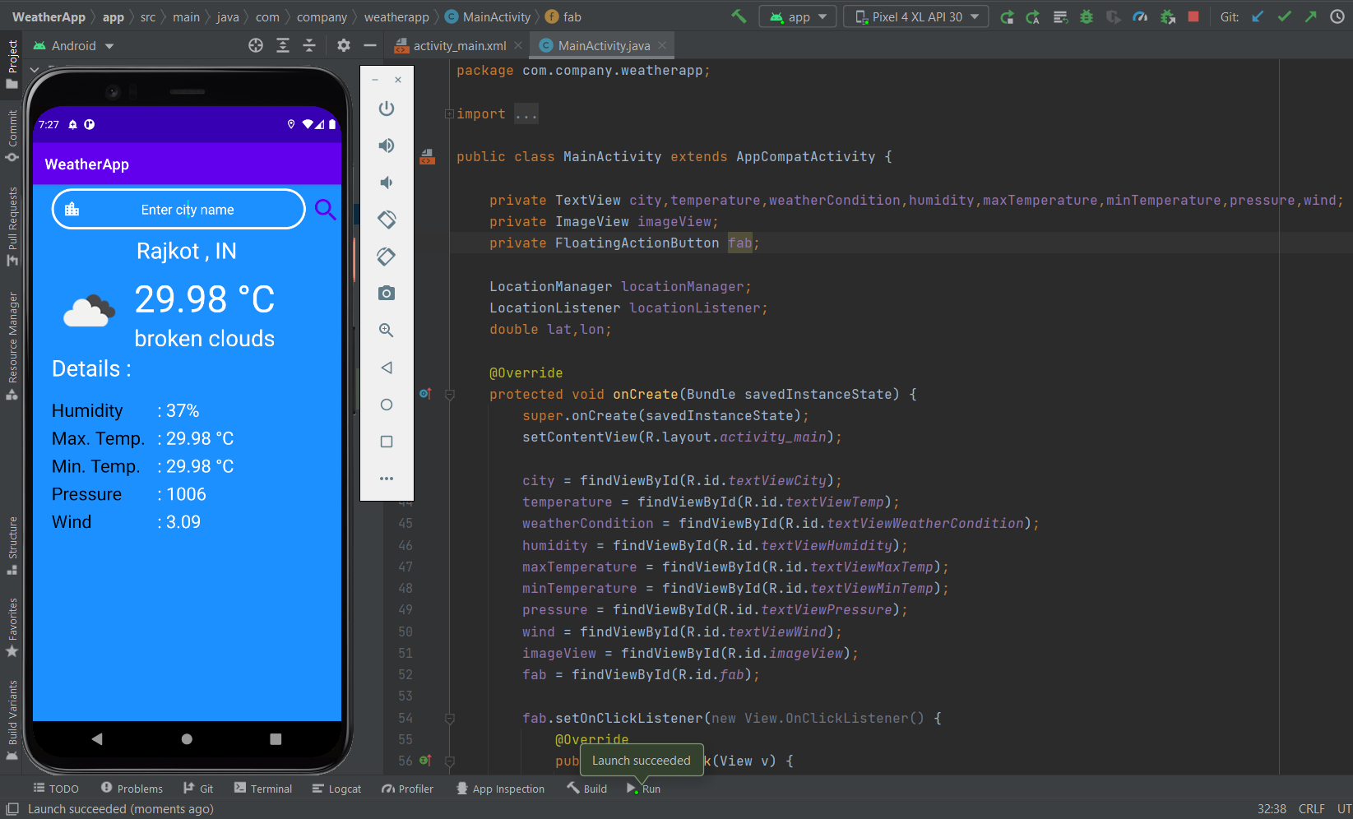

**Assignment – 2**

1. **Mini Project: Tic-Tac-Toe Game**

Code link - <https://github.com/Darshan-upadhyay1110/MyAndroidApps/tree/master/ttt>

**Activity_main.xml**

**MainActivity.java**

package com.example.ttt;

import androidx.appcompat.app.AppCompatActivity;

import android.os.Bundle;

import android.view.View;

public class MainActivity extends AppCompatActivity {

int player=0; int countP1=0; int countP2=0;

int[] gameState={2,2,2,2,2,2,2,2,2};

int[][] winpos={{0,1,2}, {3,4,5}, {6,7,8},

{0,3,6}, {1,4,7}, {2,5,8},

{0,4,8}, {2,4,6}};

@Override

protected void onCreate(Bundle savedInstanceState) {

super.onCreate(savedInstanceState);

setContentView(R.layout.activity_main);

}

public void OnTap(View view) {

ImageView img=(ImageView) view;

int tagnum=Integer.parseInt(img.getTag().toString());

if(gameState[tagnum]==2)

{

gameState[tagnum]=player;

img.setTranslationY(-1000f);

if(player==0)\{

img.setImageResource(R.drawable.o);

player=1;

}

else{

img.setImageResource(R.drawable.x);

player=0;

}

img.animate().translationYBy(1000f).setDuration(300);

}

for(int[] a:winpos) {

if(gameState[a[0]]==gameState[a[1]]&&gameState[a[1]]==gameState[a[2]]&&gameState[a[0]]!=2) {

if(gameState[a[0]]==0)

{

Toast.makeText(this,"Player 1 Win",Toast.LENGTH_SHORT).show();

countP1++;

TextView p1=(TextView)findViewById(R.id.scoreOfP1);

String setp1=""+countP1;

p1.setText(setp1);

reset(view);

}

else

{

Toast.makeText(this,"Player 2 Win",Toast.LENGTH_SHORT).show();

countP2++;

TextView p2=(TextView)findViewById(R.id.scoreOfP2);

String setP2=""+countP2;

p2.setText(setP2);

reset(view);

} } } }

public void reset(View view) {

for(int i=0;i<gameState.length;i++)

{

gameState[i]=2;

}

((ImageView)findViewById(R.id.image0)).setImageResource(0);

((ImageView)findViewById(R.id.image1)).setImageResource(0);

((ImageView)findViewById(R.id.image2)).setImageResource(0);

((ImageView)findViewById(R.id.image3)).setImageResource(0);

((ImageView)findViewById(R.id.image4)).setImageResource(0);

((ImageView)findViewById(R.id.image5)).setImageResource(0);

((ImageView)findViewById(R.id.image6)).setImageResource(0);

((ImageView)findViewById(R.id.image7)).setImageResource(0);

((ImageView)findViewById(R.id.image8)).setImageResource(0);

}

public void resetPlayrerscore(View view) {

countP1=0;

countP2=0;

String p1=""+countP1;

String p2=""+countP2;

TextView rp1=findViewById(R.id.scoreOfP1);

rp1.setText(p1);

TextView rp2=findViewById((R.id.scoreOfP2));

rp2.setText(p2);

}

}

